SCAN FOR MEET RESULTS!
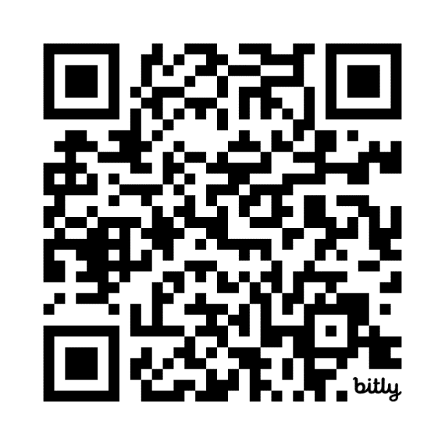
www.bit.ly/FebruaryFreeze
Shocker Track Club February Freeze Results

