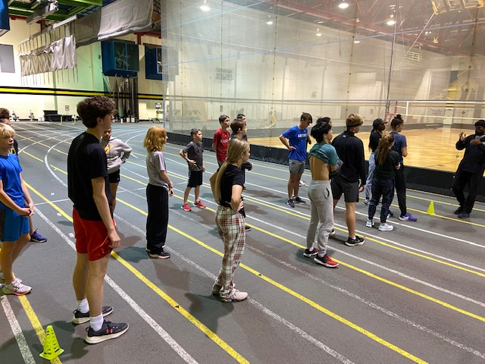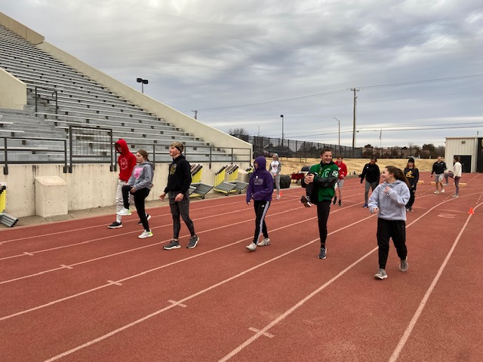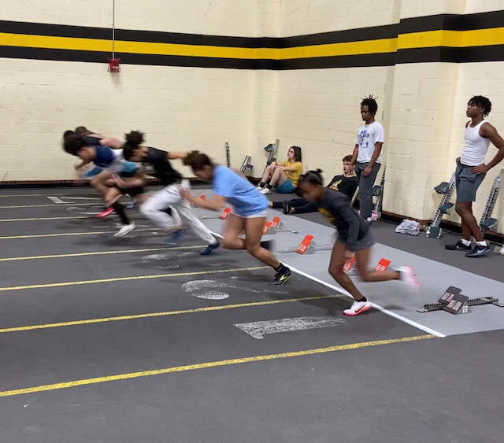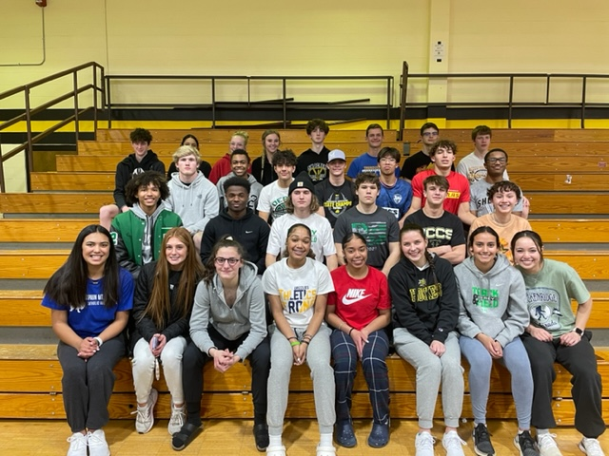  

Mission and Vision

The Shocker Track Club Youth Team operates under the auspices of the Shocker Track Club Board of Directors. Separate indoor and outdoor seasons provide opportunities for eleven months of training.

The Mission of the Shocker Track Club Youth Team is to provide opportunities for youth to train and develop in track and field, from an introductory level to high-level competition, under the framework of USATF guidelines.

Support is provided for high school athletes interested in competing at the collegiate level. Meetings can be scheduled with parents and athletes to discuss the collegiate eligibility and recruiting process.

Parents

Parents are important to the success of the athlete and the track club’s activities. We thus ask the parents to observe the following:

* Maintain a positive attitude and pay all fees in a timely manner.
* Understand that once an athlete is at a given facility, they are under the supervision/jurisdiction/guidelines of the STC Youth Team management and coaching staff.
* Remain in the seating area at practices and meets.
* Ask questions of STC Youth management and coaches at an appropriate time and in an appropriate manner.
* Consider volunteering or joining our Open or Masters Teams!

Shocker Track Club

[www.ShockerTrackClub.com](http://www.ShockerTrackClub.com)

Youth Team

*General Program Information Only  
Contact us for Complete Details*

Ages 8 through 18

#SuccessIsntGivenItsEarned

Indoor 2022 - 2023

Track Meets  
Participating in Track Meets is optional and at the expense of parents unless stated otherwise. Some travel may be required. At least two meets are intended for all ages of youth athletes, with others designated for high school athletes only. A complete list of Track Meets will be published when complete.

Registration Fees  
The Joiner Registration Fee is $130 for the first month of participation. ***Additional fees of $25 for participating in each additional month may be combined to increase the initial Joiner Registration Fee to $155.*** See the Youth Operations Director for complete and specific information. The Registration Joiner Fee includes two STC team t-shirts, a gear-bag, and free participation in the STC Youth Indoor Meet.

Staying Informed  
Weekly newsletters are issued to parents of registered children.

Practices  
Track & Field practices are held on the Wichita State University campus in multiple facilities that we rent for our use. Three practices are typically scheduled weekly between October and February, with many optional practices available for detail work.

The Indoor Training Program  
The Indoor Program training begins on October 3, 2022, lasting through February 24, 2023. Coaching for Youth athletes **ages 8 through 18** in every indoor event is provided.

Coaches  
All STC Youth Coaches AND Leaders are USATF members, have passed the USA Track & Field/NCSI background check, and completed the USOC SafeSport training. All Coaches have competition experience, with some having NCAA, NAIA, and post-collegiate experience. Coaches “deliver” proven practice and workout strategies developed through various experiences, research, and collaboration with universities and professional organizations.

Program Management  
The Shocker Track Club Youth Team is a USATF Member Club managed by a Director, with assistance from the Youth Operations Director and Head Event Coaches. They are responsible for planning and leading all activities, including: team organization, training activities for athletes and coaches, overall training template, oversight of membership activities, and co-direction of any STC Youth home meets. STC is the only youth track club that provides nearly year-round coaching in every event with connections to NCAA D1 and NAIA universities.

1845 Fairmount

Wichita, Kansas 67260

(316) 993-6824

[youth@shockertrackclub.com](mailto:youth@shockertrackclub.com)

[youthoperations@shockertrackclub.com](mailto:youthoperations@shockertrackclub.com)

The Shocker Track Club (STC) is a 501(C)(3) organization that helps support Wichita area Track and Field and Cross-Country activities.

STC MISSION

LEADERSHIP

YOUTH PROGRAMS