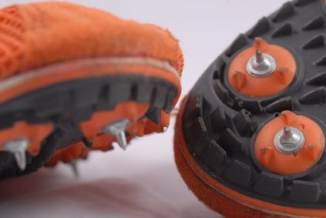

Skylar Arneson Throws/Highland Games

Dominic Artis Sprints

Meghan Holmes Horizontal Jumps

Airick Johnson Hurdles

Brittany Kallenberger Pole Vault

Tyler Knight Pole Vault

Nicholas Meyer Pole Vault

Katie Murray High Jump

Tonya Nero Long Distance

Chris Peters Multi-Events

Samantha Shukla Long Distance

Aaron True Javelin

The Shocker Track Club Elite Team is managed by:

* John Wise, Director
* John “JK” Kornelson, Head Coach
* Tyler Knight, Athlete Liaison

Shocker Track Club Elite Team will appreciate your support!

1845 Fairmount

Wichita, Kansas 67260

(316) 978-5544

[president@shockertrackclub.com](mailto:president@shockertrackclub.com)

[ShockerTrackClub.com](http://www.shockertrackclub.com)

Sponsorship Program

A T H L E T I C S H O E S

for

Elite Track & Field Team

2018 - 2019

# Shocker Track Club Elite Team Members

SHOCKER TRACK CLUB

ATHLETIC SHOE SPONSORSHIP PROGRAM

The estimated value of the annual sponsorship is approximately $6,000 ($150 per pair X two pair X 20 athletes).

The successful sponsor can -

(a) donate shoes to the Shocker Track Club, Inc., be provided to Elite Team athletes under contract with Shocker Track Club,

(b) donate funds to STC to be used to purchase shoes, or

(c) provide vouchers to be used for the purchase of shoes by the Elite Team athletes.

**STC will provide the sponsor with -**

**(a) a logo/link on its website -**[**www.shockertrackclub.com**](http://www.shockertrackclub.com) **,**

**(b) regular acknowledgement of the sponsorship on social media by STC and recipient athletes,**

**(c) a 2'x5' vinyl banner to be displayed at STC events in which STC Elite Track and Field and Road Racing athletes will be competing, and**

**(d) up to two appearances by 1-4 STC Elite athletes at special events at the sponsor’s retail location.**

*A sponsor can also offer discounts for the purchase of other shoes to be made by members of other STC athletics teams (e.g., Open, Youth, and Masters team athletes), and other individuals affiliated with STC.*

**STC will provide a formal letter of acknowledgment of the sponsorship gift that can be used for tax preparation purposes.**

THE TEAM  
The Shocker Track Club Elite Team is comprised of former Wichita State University and other post-collegiate athletes invited to compete for the team via an application process. The chosen athletes showcase strong efforts to meet certain standards.  A Team Jury reviews all applications for team membership. STC Elite members are expected to compete at an elevated level of track and field, serve as positive role models, and represent STC and the community in a professional manner. Qualifying performances must be within the past three years and achieved at a sanctioned meet.

STC Elite must complete an Agreement with Shocker Track Club, be a current USATF member, pass the USATF background check, and abide by the USATF Code of Conduct.

Athletes selected for team membership are provided with a team uniform (singlet, t-shirt, full warm-up suit), and other STC accessories.

ATHLETIC SHOE NEEDS  
The Shocker Track Club (STC) is in need of sponsorship for athletics shoes for its Elite Track and Field and Road Racing Team members.

Between 10 and 20 athletes are members of the STC Elite Track and Field and Road Racing teams and are in need of at least two (2) pairs of specialty athletic shoes - one for training and one for competition.

The Shocker Track Club is a 501(C)(3) non-profit organization, donations made to Shocker Track Club, Inc., are eligible for allowable tax deductions. Donations of any amount can be made at any time and are acknowledged by official letter from the Board of Directors recognizing the donated amount.

**STC will enter into a formal Agreement with the sponsor to clearly delineate the specifics of the sponsorship.**

[ShockerTrackClub.com](http://www.shockertrackclub.com)

Shocker Track Club Elite Team

Elite Team Shoe Sponsorship

The Shocker Track Club (STC) is a 501(C)(3) organization that helps support Wichita area Track and Field and Cross Country activities.

MISSION