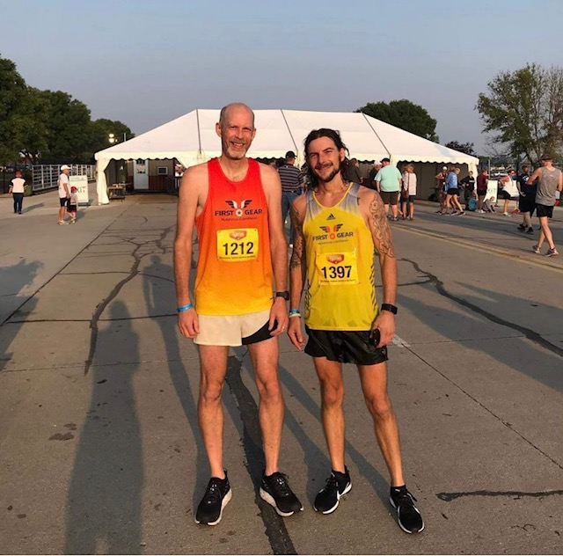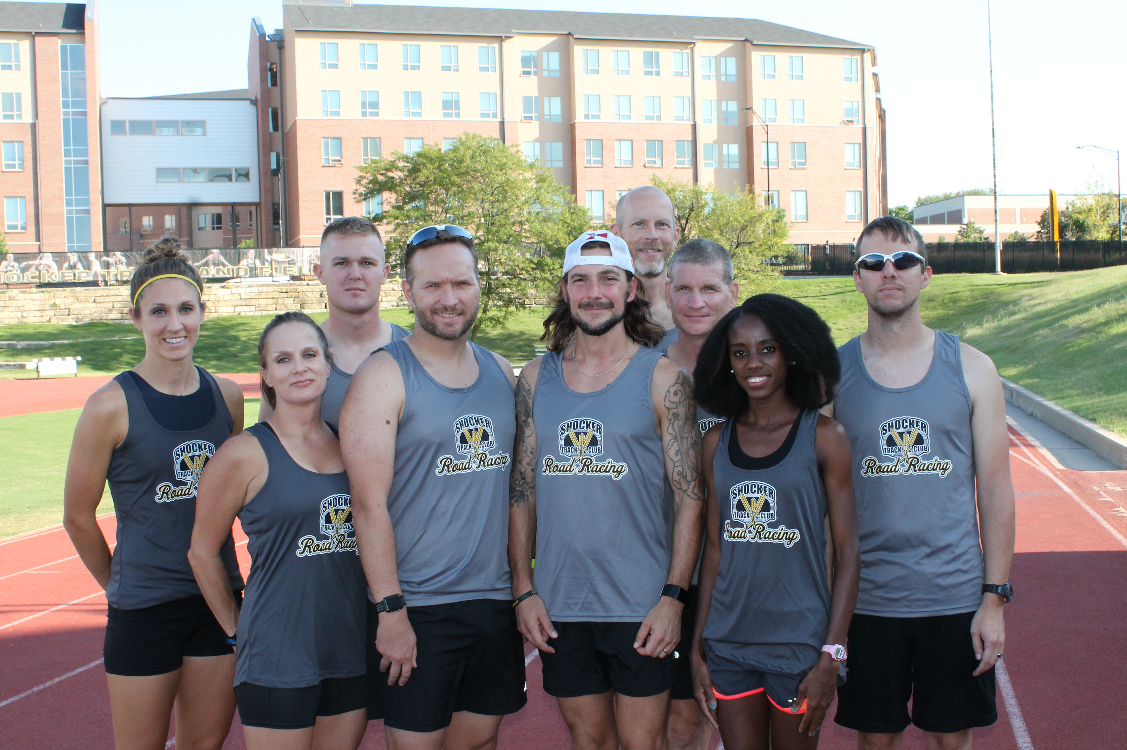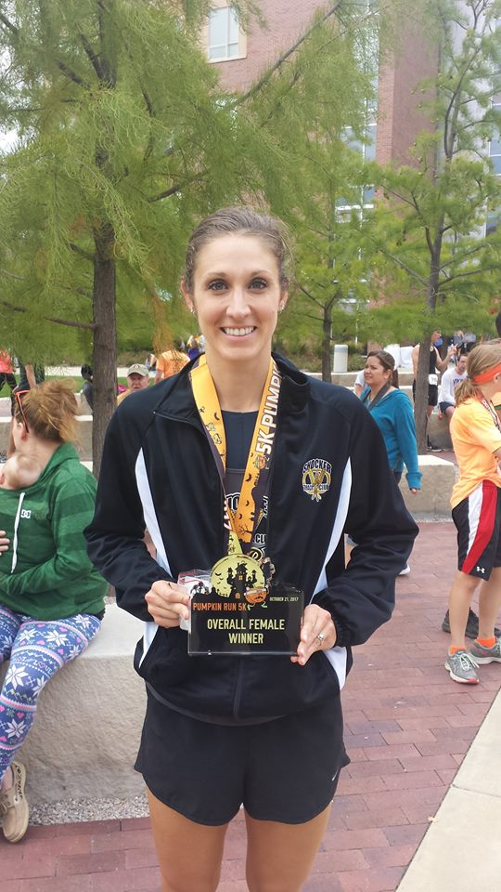 

#### ShockerTrackClub.com @STCRoadRacing

2019-2020

USATF Affiliation  
The Shocker Track Club is affiliated with USA Track & Field through the Missouri Valley Association. Membership in USATF is not required for Shocker Track Club Distance Project team members, but is **strongly encouraged** because of the many benefits. Details are available at www.USATF.org.

Mission and Vision   
The Shocker Track Club Road Racing Team operates under the auspices of the Shocker Track Club Board of Directors and premier sponsor, First Gear Running Company.

The mission of the **Shocker Track Club Road Racing Team** is to offer a training and competition forum for the adult distance runner. All runners from casual to serious runners are welcome! The program is focused on raising the standard for Kansas road running and assisting local talent to accomplishing their dreams through guidance and opportunity.

Shocker Track Club

Road Racing Team

Membership - $120 annually  
The membership fee includes: coaching, team leadership, coaching strategies from Wichita State University Cross-Country, weekly strategic practices led by team Co-Directors, Shocker Fitness Trainer (and former Wichita State University Multi-Event Athlete) Emily Green Maier and Curt Rierson, a team competition jersey, long-sleeve t-shirt, shoe purchase discount at team sponsor First Gear Running Company, and a donation to the team foundation to support Road Racing Team Elite athletes

Program Director  
The Shocker Track Club Road Racing Team is managed by the Team Co-Directors who are responsible for planning meets and training activities, oversight of membership activities, fundraising, and co-direction of all activities.

Coaching and Practice  
Practice and workout strategies have been developed by the coaching staff of Wichita State University. Practice time is available during the indoor season at the Wichita State University Heskett Center and Wichita State University Cessna Stadium during the outdoor season.

Communication  
Road Racing Team information is distributed via email. Contact [roadracing@shockertrackclub.com](mailto:roadracing@shockertrackclub.com) to be included.

Running Events  
STC hosts one road race annually for STC Road Racing athletes. Other road racing events are held in the greater Wichita community and beyond.

1845 Fairmount

Wichita, Kansas 67260

(316) 978-5544

roadracing@shockertrackclub.com

Uniforms and Gear  
A Shocker Track Club Road Racing Team competition jersey and a long-sleeve t-shirt are provided to all paid members. Additional uniform components are available for purchase. A discount shoe purchase program is sponsored by First Gear Running Company.

The Shocker Track Club (STC) is a 501(C)(3) organization that helps support Wichita area Track and Field and Cross Country activities.

STC MISSION

LEADERSHIP

ROAD RACING TEAM PROGRAM