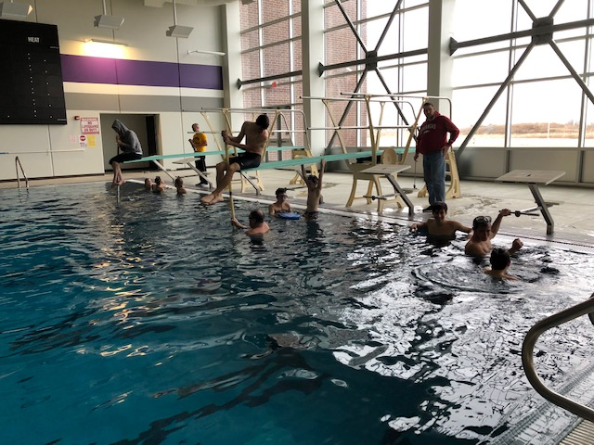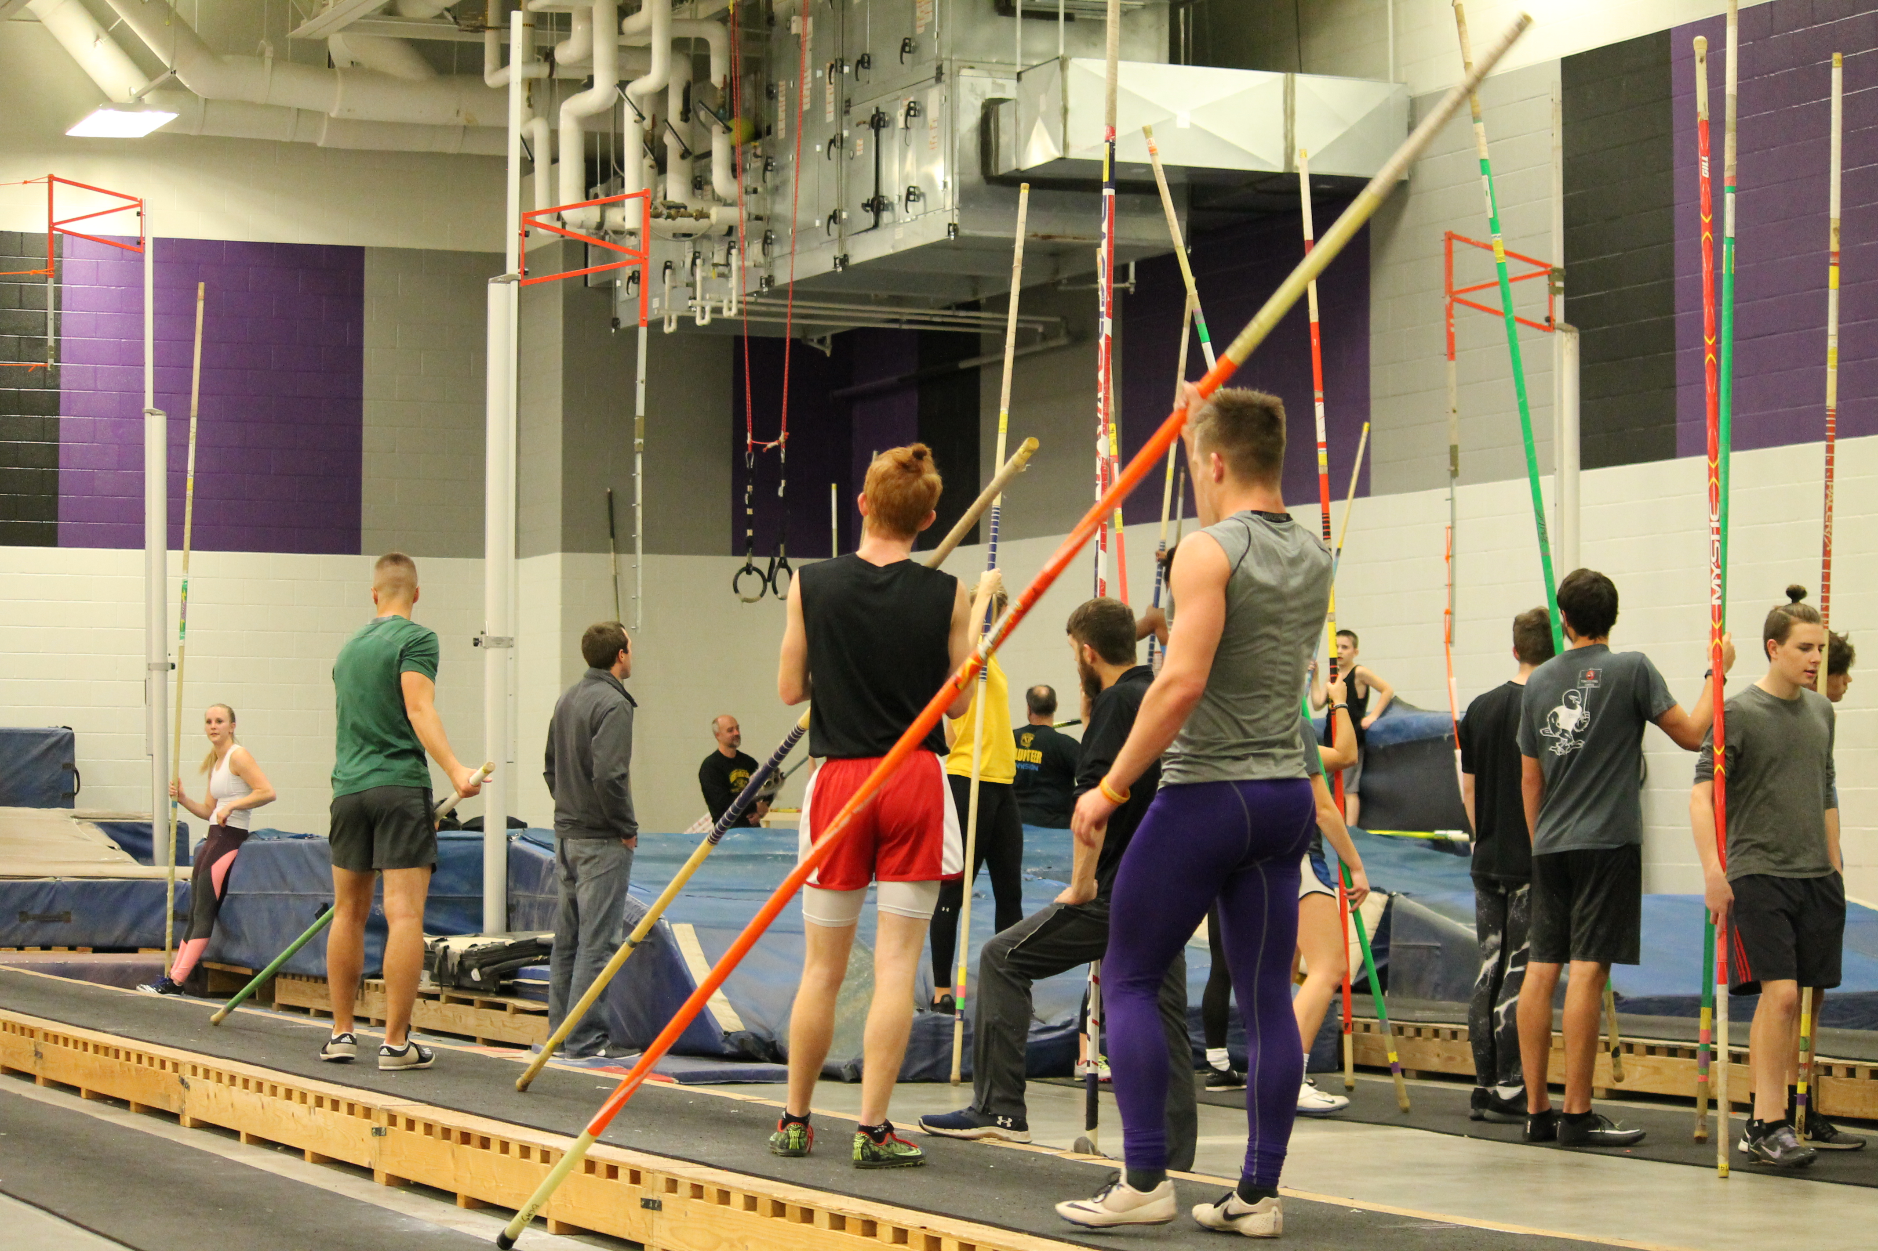 

All Ages!

POLE VAULT

**Eleven (11) State Champions **

#### ShockerTrackClub.com

Shocker Track Club

Parents  
Parents are important to the success of the athlete and the track club and we ask the parents to observe the following:

* Maintain a positive attitude
* Pay all fees in a timely manner
* Realize that once an athlete is at a given facility, they are under the supervision/jurisdiction/guidelines of the STC Youth Team management and coaching staff
* Ensure that the athlete is at practice and at meets on time
* Remain in the seating area at practice and meets
* Ask questions of STC Pole Vault Group management and coaches at an appropriate time and in an appropriate manner

Organization and Mission   
The Shocker Track Club Pole Vault Group is part of the Shocker Track Club Youth Team operates under the auspices of the Shocker Track Club Board of Directors. Separate indoor and outdoor seasons provide opportunities for nearly eight months of training.

*The Mission of the Shocker Track Club Youth Team is to provide opportunities for youth to compete in track and field from an introductory level, to high-level competition, under the framework of USATF guidelines.*

Indoor 2019 - 2020

Future Success   
Sixteen (16) Pole Vaulters qualified for the 2019 State High School Track Meet in various classes. Additionally, athletes that have participated in the STC Pole Vault program have moved on to compete at Wichita State University, Kansas State University, US Army-West Point, North Carolina A&T, Louisiana-Monroe, Fort Hays State University, Emporia State University, Missouri Southern University, Friends University, Missouri S&T University, and Fresno Pacific University.

Coaches  
The Coaches are responsible for the day-to-day training, practices, and meet day preparation. All have NCAA Division 1, 2, or NAIA competition experience. Coaches and are also USATF members, have passed a USA Track & Field background check, and completed the USOC SafeSport training. 2019-2020 Coaches are -

* Head Coach – Denis Fraizer ([polevault@shockertrackclub.com](mailto:polevault@shockertrackclub.com))
* Lead Asst Coach – Andrew Brown
* Lead Asst Coach – Paul Wagoner
* Lead Asst Coach – Jaimie Bookout

Staying Informed   
Weekly Newsletters keep Parents and Athletes informed of all activities. Short “gather ‘round” meetings are occasionally held at practices.

Meets  
Track meets are held throughout Kansas and in surrounding states beginning in January. Participation in track meets is optional, and at the personal expense of the athlete. Coaches attend all meets.

Registration Fees   
Pay one-time to Join in November for $190, December for $170, January for $150, or February for $130. Athletes can join at any time! Season fees include group and one-on-one instruction, a STC team t-shirt, jersey, gear-bag, water bottle, wristband, and free participation in the STC Bill Butterworth Indoor Meet in January.

Practices  
Pole Vault practices are held at USD 259 Northeast Magnet High School at 5550 N. Lycee Street in Bel Aire, Kansas beginning on Saturday, November 1, 2019, and continuing through Saturday, February 22, 2020. Practices are Tuesday and Thursday evenings from 630p to 830p, and Saturdays from 100p to 300p. Coaching includes use of training apparatus, pole vault poles and equipment, and monthly (optional) swimming pool drills.

The Pole Vault Program  
The STC Pole Vault Program is for Vaulters of ALL ages. It is managed by the Team Dad and Head Pole Vault Coach. They are responsible for planning and leading all activities, including: team organization, training activities for athletes and coaches, overall training template, oversight of membership activities, and co-direction of participating in meets and other organized activities.

REGISTRATION

LEADERSHIP

1845 Fairmount

Wichita, Kansas 67260

(316) 978-5544

[youth@shockertrackclub.com](mailto:youth@shockertrackclub.com)

[polevault@shockertrackclub.com](mailto:polevault@shockertrackclub.com)

The Shocker Track Club (STC) is a 501(C)(3) organization that helps support Wichita area Track and Field and Cross Country activities.

STC MISSION