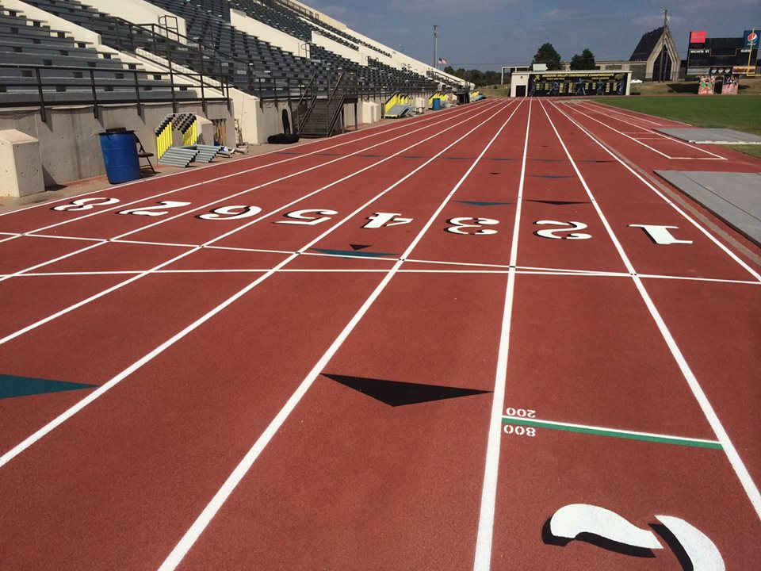 

Leadership Meetings  
Open Team membership meetings are held annually. Watch www.ShockerTrackClub.com for details.

USATF Affiliation

The Shocker Track Club is affiliated with USA Track & Field through the Missouri Valley Association. Membership in USATF is not required for Shocker Track Club Open team members, but it is strongly encouraged because of the many benefits. Details are available at www.USATF.org.

Organization and Mission

The Shocker Track Club Open Team is for adult athletes up to the age of 30 and operates under the auspices of the Shocker Track Club Board of Directors. Separate indoor and outdoor seasons provide opportunities for nearly year-round training.

*The Mission of the Shocker Track Club Open Team is to provide opportunities for current college students not competing for their university, or post collegiate athletes to continue to train and compete in track and field under the framework of USATF guidelines.*

Shocker Track Club

#### ShockerTrackClub.com

Open Team

2019 - 2020

Coaching and Practices  
Practice and workout strategies have been developed by the Wichita State University Track & Field Coaching staff along with input from experienced coaches.

STC Open Team Gold - $150 Annual Membership  
This is an **annual membership** and includes Team benefits and amenities from October through February **AND** March through September.

This membership includes a Shocker Track Club black singlet AND a black short-sleeve t-shirt or a long-sleeve t-shirt and access to: (1) the Wichita State University Heskett Center for indoor practice time between October and late-February on select days and times when the Shocker Track Club Youth Track and Field Team trains (the STC Indoor Pole Vault program is NOT included), AND,

(2) Wichita State University Cessna Stadium Track for outdoor practice time between April and late-July on select days and times when the Shocker Track Club Youth Team trains. Pole Vault training in June and July is included.

Free participation in up to three open competition meets with the approval of Wichita State University T&F Leadership -

(1) Indoor Wichita State University Track and Field meet

(2) Outdoor Wichita State University hosted Track and Field meet

(3) Wichita State University Cross-Country meet

STC Open Team Black - $80 Seasonal Membership  
This is a **season membership**; team benefits and amenities are provided for:

1. Indoor Training - October through February **OR**
2. Outdoor Training - March through September

This membership includes a Shocker Track Club black singlet or SS black t-shirt, or LS black t-shirt, and access to either:

(1) the Wichita State University Heskett Center for indoor practice time between October and late-February on select days when the Shocker Track Club Youth Track and Field Team trains (the STC Indoor Pole Vault program is NOT included), OR,

(2) Wichita State University Cessna Stadium Track for outdoor practice time between April and late-July on select days when the Shocker Track Club Youth Track and Field Team trains. Pole Vault training in June and July is included.

Free participation in any one (1) open competition meet with the approval of Wichita State University T&F Leadership -

(1) Indoor Wichita State University Track and Field meet, OR

(2) Outdoor Wichita State University Track and Field meet, OR

(3) Wichita State University Cross-Country meet

Team Director / Coaching and Practices  
The Shocker Track Club Open team is managed by the Director of the Open Team who is responsible for managing membership information and planning training activities for athletes. Contact Dylan Hartnett at [openteam@shockertrackclub.com](mailto:openteam@shockertrackclub.com) with any questions.

MEMBERSHIP and COACHING

LEADERSHIP and MEMBERSHIP

The Shocker Track Club (STC) is a 501(C)(3) organization that helps support Wichita area Track and Field and Cross Country activities.

1845 Fairmount

Wichita, Kansas 67260

(316) 978-5544

masters@shockertrackclub.com

STC MISSION