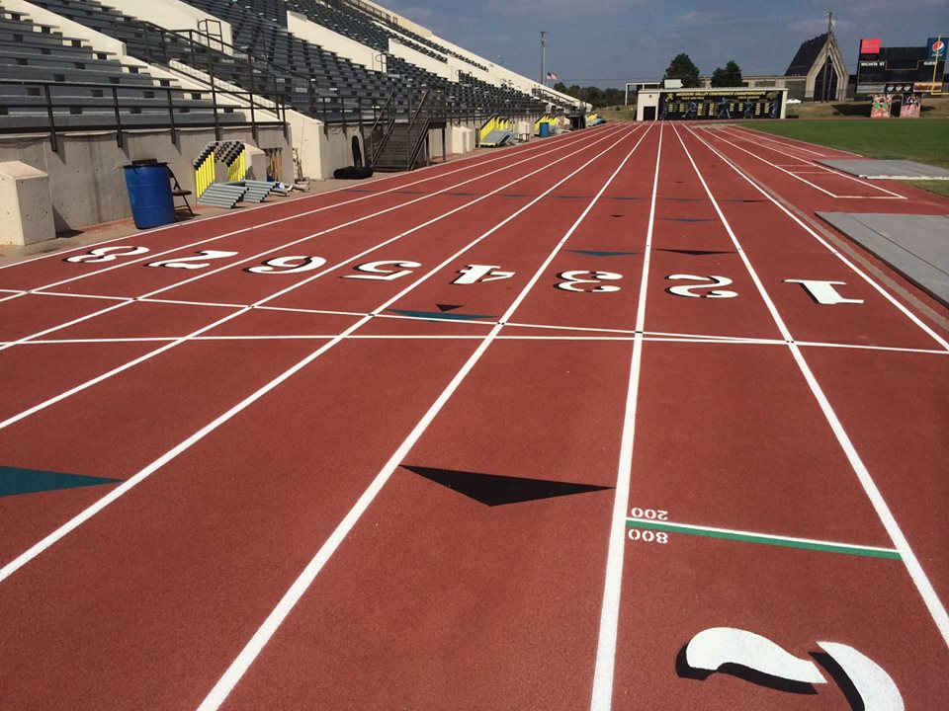 

Shocker Track Club

#### ShockerTrackClub.com

Open Team

# Mission and Vision

The Shocker Track Club Open Team is for adult athletes up to the age of 30 and operates under the auspices of the Shocker Track Club Board of Directors. Separate indoor and outdoor seasons provide opportunities for nearly year-round training.

**The Mission of the Shocker Track Club Open Team is to provide opportunities for post collegiate athletes to continue to compete in track and field under the framework of USATF guidelines.**

# USATF Affiliation

The Shocker Track Club is affiliated with USA Track & Field through the Missouri Valley Association. Membership in USATF is not required for Shocker Track Club Open team members, but it is strongly encouraged because of the many benefits. Details are available at www.USATF.org.

2018-2019

This membership includes a Shocker Track Club black singlet or yellow t-shirt and access to either: (1) the Wichita State University Heskett Center for indoor practice time between mid-November and mid-February on select days, **OR,** (2) Wichita State University Cessna Stadium Track for outdoor practice time between October and late February on select days, when the Shocker Track Club Youth Team trains.

# Volunteerism - Priceless

Unless competing, Shocker Track Club Open Team members are asked to help with the facilitation of Wichita State University and Shocker Track Club meets.

This membership includes all of the benefits of the Black Membership plus free participation in the WSU Summer Series Track Meets (Thursday nights) at Cessna Stadium during June and July.

The Shocker Track Club (STC) is a 501(C)(3) organization that helps support Wichita area Track and Field and Cross Country activities.

# STC Gold Membership – $100 annually

# STC Black Membership - $60 annually

# 0

Open Team committee meetings are held annually. Watch www.ShockerTrackClub.com for details.

**Leadership Committee Meetings**

Practice and workout strategies have been developed by the Wichita State University Track & Field Coaching staff along with input from experienced athletes. Practice time is available during the indoor season at the Wichita State University Heskett Center and Wichita State University Cessna Stadium during the outdoor season.

### Coaching and Practice

The Shocker Track Club Open team is managed by the Director of the Open Team who is responsible for planning training activities for athletes. Contact Dylan Hartnett at openteam@shockertrackclub.com.

1845 Fairmount

Wichita, Kansas 67260

(316) 978-5544

masters@shockertrackclub.com

STC MISSION

### Program Director

LEADERSHIP

OPEN TEAM PROGRAMS