REGISTRATION INFORMATION

SHOCKER TRACK CLUB
2017
Summer Jumps Fest
Pole Vault
Other Jumping Events Available

INFORMATION PACKET
USA Track & Field Sanctioned

Saturday, June 17, 2017
Wichita State University Cessna Stadium
Wichita, Kansas

Online Registration
www.STCJumpsFest.com

SHOCKER TRACK CLUB
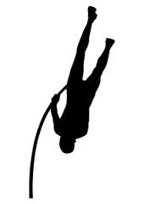
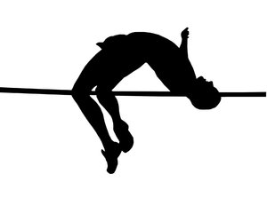

SUMMER JUMPS FEST 2017

Certified Officials will conduct the events in accordance with USA Track & Field Rules

Saturday, June 17, 2017
Wichita State University Cessna Stadium
Competitions begin at 9:00 a.m.
YOUTH then ELITE then OPEN

Registration Fee - $40.00
Provides Event T-Shirt, Sunglasses, and souvenir program
Registration now through the deadline of June 15, 2017
Late Registration Fee is $50 AFTER June 5, 2017 and subject to availability

Online Registration
www.STCJumpsFest.com

SHOCKER TRACK CLUB
SUMMER JUMPS FEST 2017

POLE VAULT
Youth Girls and Youth Boys – NO MINIMUM ENTRY MARKS
Open Women (10’-00” (3.05m)) and Open Men (14’-6” (4.11m))
Elite Women – Minimum Entry Mark of 13’-0” (3.96m)
Elite Men – Minimum Mark of 17’-6 1/2” (5.35m)

9:00 a.m. Start - Youth Girls and Youth Boys (Up to age 18)
12:30 p.m. Start - Elite (high level competitors) for Women and Men
4:00 p.m. Start - Open for Women and Men
Trophies/Medals will be awarded to the top four finishers in each competition group

OTHER JUMPING EVENTS
TRIPLE JUMP
HIGH JUMP
LONG JUMP
Open and Elite Women and Men
(Age 16 and up)
10:00 a.m. Start – Women then Men

Pole Vault Questions?
Contact Denis Fraizer at 316-680-0852 or
polevault@shockertrackclub.com

Other Jumping Event Questions?
Contact Darren Muci at (316) 993-6824 or president@shockertrackclub.com

SHOCKER TRACK CLUB

SUMMER JUMPS FEST 2017

Spectators are welcome!
NO CHARGE!

Field Level and Stadium Seating available
Bring your lounge chairs

Concessions Available!

Records
Pole Vault
Youth Girls Nicole Kallenberger 3.81m (12’-6”) 2015
Youth Boys Christian Compton 4.72m (15’-6”) 2015
Open Women Brittany Kallenberger 4.11m (13’-6”) 2015
Open Men Chris Nilsen 5.02m (16’-06”) 2015
Elite Men Jack Whitt (Nike) 5.70m (18’-7”) 2015
Cessna Stadium Men Earl Bell 5.65m (18’-7-1/4”) 1976
Cessna Stadium Women Natalie Willer 4.20m (13’-9-1/2”) 2011

High Jump
Cessna Stadium Men Nathan Leeper 2.26m (7’-5”) 2002
Cessna Stadium Men Jah-Nhai Perinchief 2.26m (7’-5”) 2016
Cessna Stadium Women Pam Spencer 1.96m (6’-5”) 1981

SHOCKER TRACK CLUB
SUMMER JUMPS FEST 2017

Parking
Parking is available in the parking lot off 21st Street between the Charles Koch Arena and Cessna Stadium.
See map below for specifics.
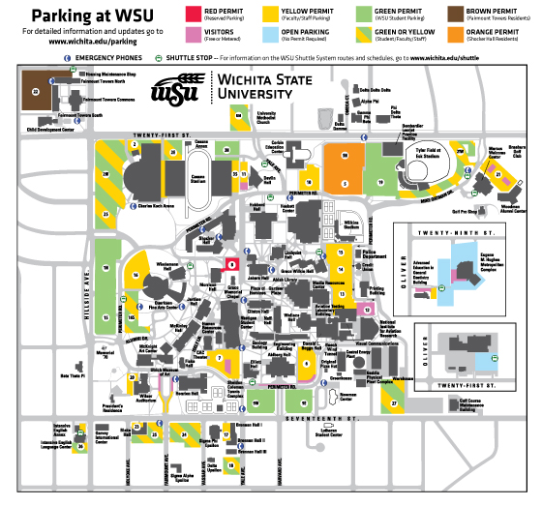

Locker rooms
Locker rooms are not available, however Cessna Stadium has large restrooms with ample room for changing.

Concessions
Concessions will be available.

