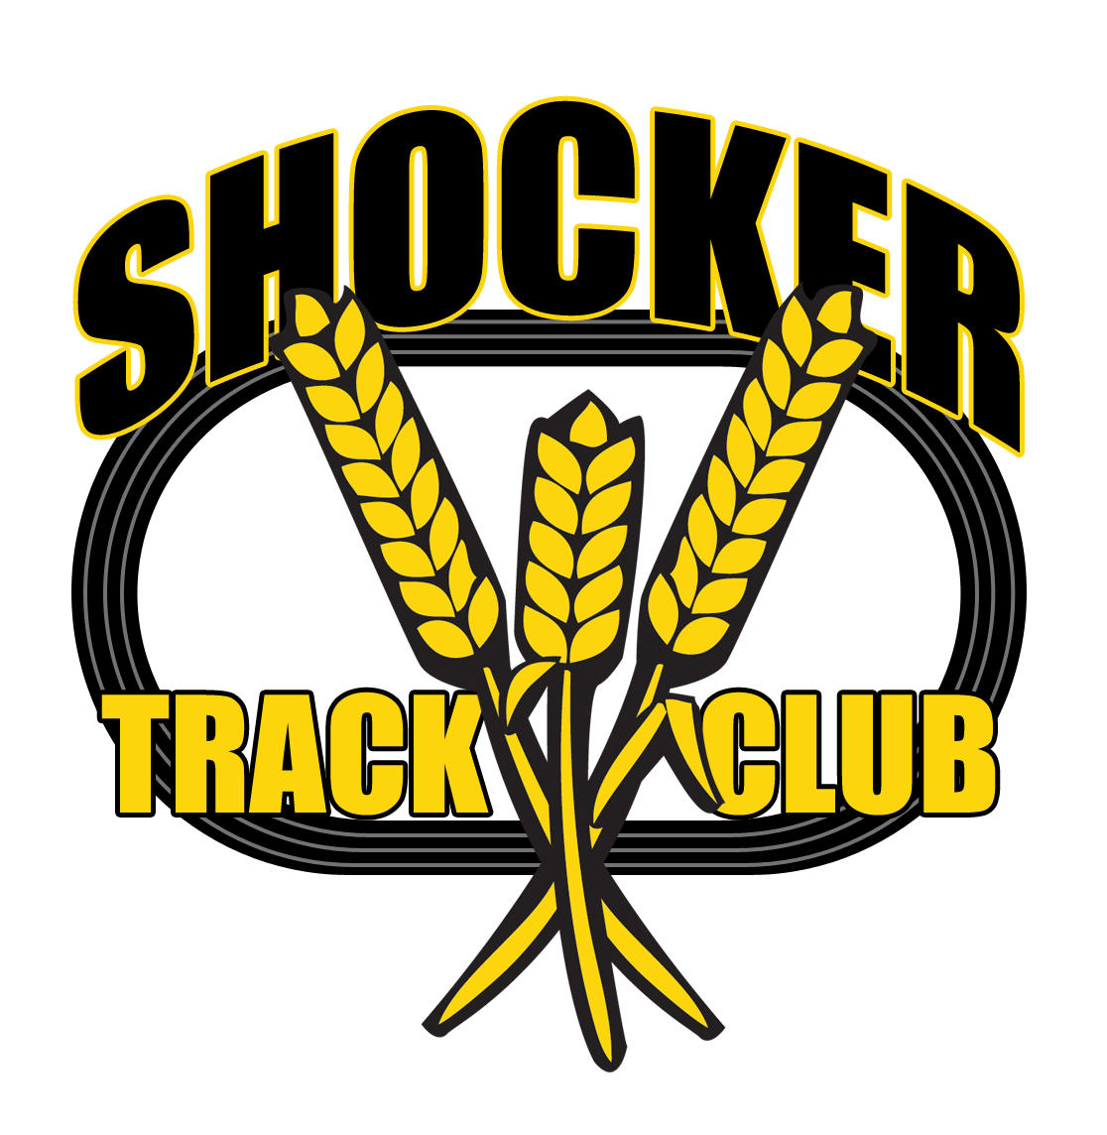
SHOCKER TRACK CLUB
Name and Logo Description and Use Information
December 14, 2015

PURPOSE
This document delineates the details of name of the organization, the use of the name, and the description and use of the organization logo.

NAME
The official name of the organization is “Shocker Track Club, Inc.” It is also known as “Shocker Track Club” and “STC”.

RIGHTS TO THE NAME
The word “Shocker” is not officially protected by Wichita State University; however, Shocker Track Club requested permission from the Wichita State University Department of Intercollegiate Athletics (WSUDIA) to use “Shocker” in its official name. The WSUDIA granted perpetual rights to the Shocker Track Club, Inc. to use the word “Shocker” in its official name on November 30, 2011, by (then) Director of Marketing, John Brewer.

NAME REGISTERED RIGHTS - STATE OF KANSAS
The State of Kansas, office of the Secretary of State, approved the Shocker Track Club, Inc., Service Mark application on February 10, 2014, under ID no. 18864. The approval is for a five-year (5) period through February 9, 2019. The approved application protects the name “Shocker Track Club” and the logo of Shocker Track Club.

FONT
In all official communication, marketing efforts, or on apparel or products, the name of the organization will always be in “Impact” font in all CAPITAL LETTERS, Capital AND Lower Case letters, or lower case letters. Slight variations are allowed (e.g., italicized, bold, separated, curved, etc.) to enhance the message or the activity.

THE ORGANIZATION LOGO
The official logo of the Shocker Track Club, Inc., shall be described as – a four (4) lane track (oval) in black in the background, the word “SHOCKER” is on top of/above, the black track oval in capital black letters, Impact font, outlined in yellow. Three (3) stalks of wheat are in yellow, outlined in black, forming a “W,” and they criss-cross over the black track oval. One of the wheat stalks touches the “H” in the word SHOCKER, another touches the “E” in the word SHOCKER, and the other stalk is just below the black track oval and the letter “C.” The word “TRACK” is in yellow capital letters, outlined in black, and it is on the left side of the three stalks of wheat and slightly above the inside of the black track oval. The word “CLUB” is in yellow capital letters, outlined in black, and it is on the right side of the three stalks of wheat and slightly above the inside of the black track oval.

The logo can be printed in black-and-white, gray scale, or any single, solid color that meets the general design description of the logo above.

ORGANIZATION NAME AND LOGO USE ON APPAREL
On all apparel items (typically shirts and jackets), the name “Shocker Track Club” using the Impact font, must appear on the front of the garment and can appear on the back. The Shocker Track Club logo can appear on the front of the garment and must appear on the back of the garment. It is understood that funding may warrant the absence of the logo from the back of a garment, but this should be on rare occasions.

On other items of apparel (e.g., hats, shorts, etc.) it is strongly preferred that the name “Shocker Track Club” using the Impact font, and the logo as described above, be used. However, it is understood that the size of the apparel item, and funding may warrant the absence of the name without the logo, or logo without the name, but this should be on rare occasions.

ORGANIZATION NAME AND LOGO USE ON ITEMS OR PRODUCTS
On all items or products it is strongly preferred that both the name “Shocker Track Club” using the Impact font, and the logo as described above, be used. However, it is understood that the size of the item or product, or funding, may dictate that either only the name “Shocker Track Club” using the Impact font, or only the Shocker Track Club logo as described above, be used.

END OF DOCUMENT

