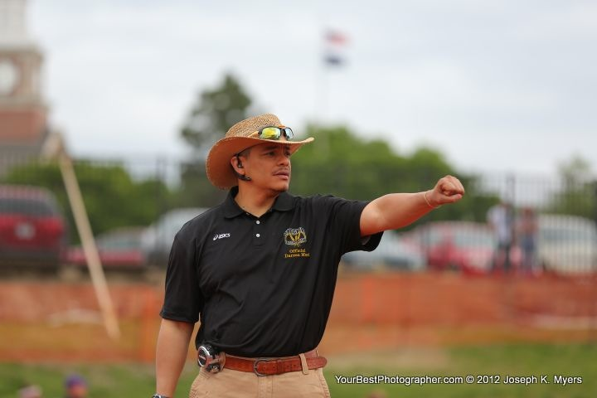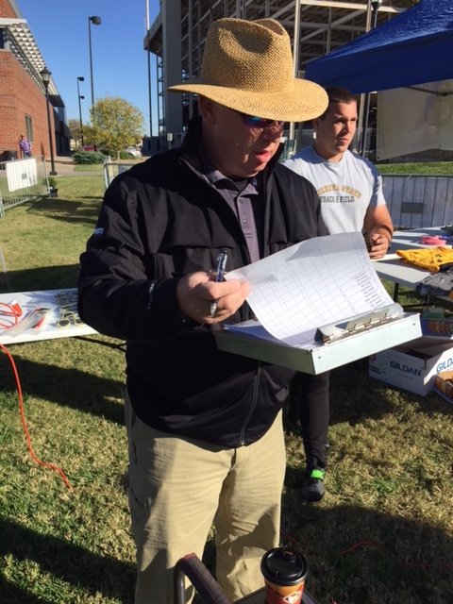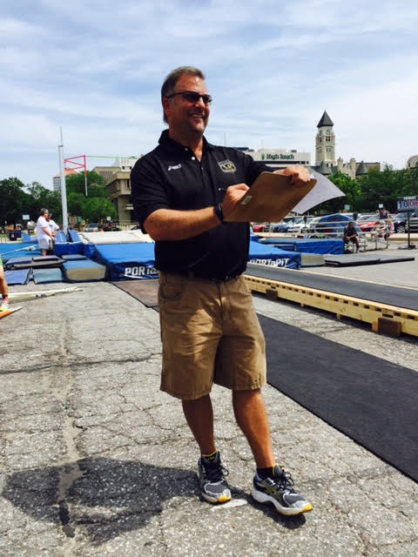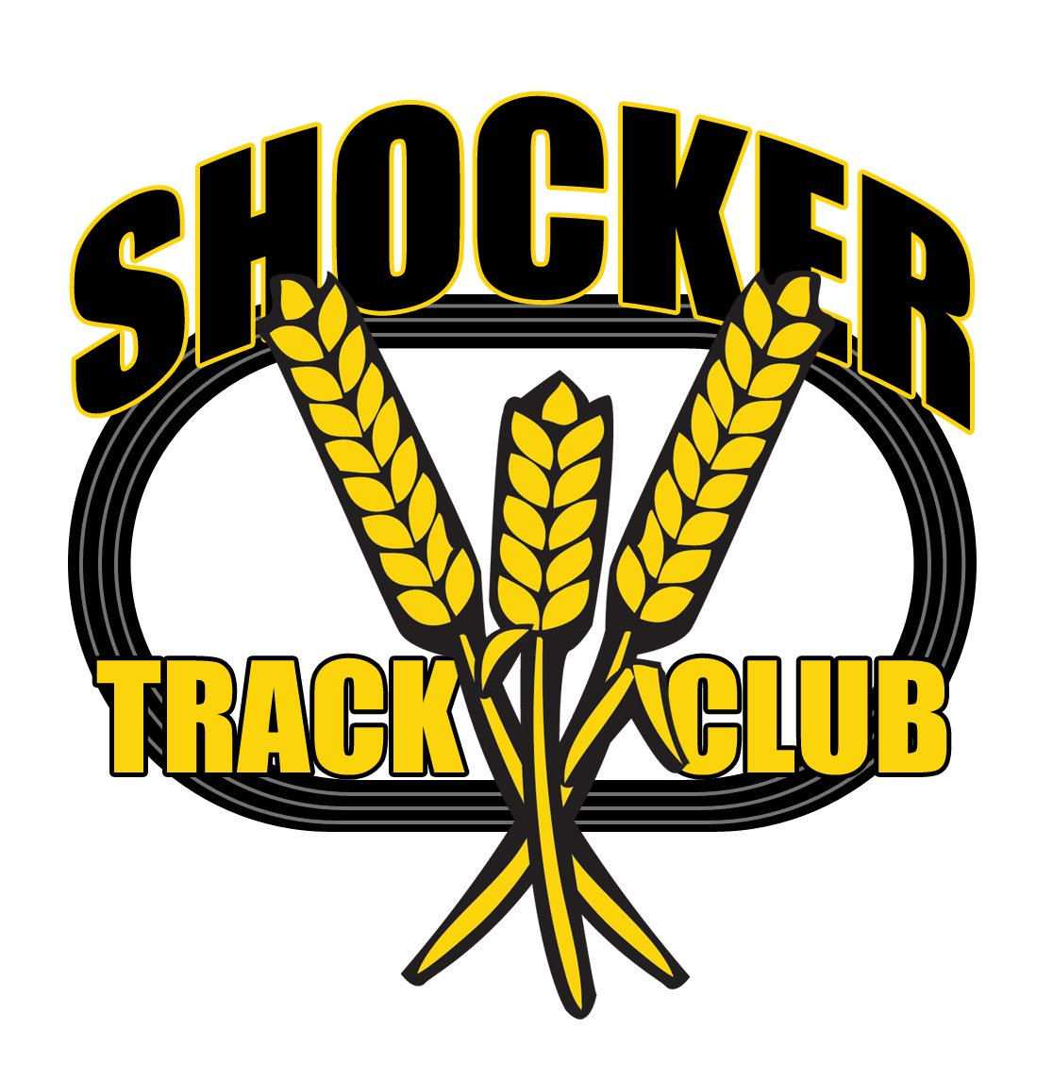  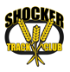



#### ShockerTrackClub.com

Shocker Track Club

2019 – 2020

Certified Officials

USATF Affiliation

The Shocker Track Club is affiliated with USA Track & Field through the Missouri Valley Association. Membership in USATF is required for Shocker Track Club Certified Officials. Officials must also complete a NCSI background check, and complete the United States Olympic Committee (USOC) SafeSport online training. USATF Membership information can be found at www.usatf.org.

Mission and Vision  
The Shocker Track Club Officials and Volunteers Corp operates under the auspices of the Shocker Track Club Board of Directors and Wichita State Track and Field.

**The Mission of the Shocker Track Club Officials and Volunteer Corp is to provide high-quality, knowledgeable, and ethical officiating services to ensure that Wichita State University, and Shocker Track Club, meets are planned and facilitated in strict compliance with applicable rules and regulations.**

DailyFees  
All Starters and Officials must be certified through USA Track and Field to be eligible for remuneration from Wichita State University Track and Field unless stated otherwise below:

- Starters - $100 per day  
- Head Event Official - $75 per day  
- Not Head or Co-Head Official - $25 - 50 per day

Officials for Shocker Track Club Meets are paid $50 per day.

**Officials may also assist in facilitating a meet but in non-officiating capacities such as - throwing event implement retrievers, bar setters, pit rakers, meal servers, event board updaters, Hip number providers, etc.**

**Wichita State University and Shocker Track Club reserve the right to determine the number of Officials needed for each event and meet.**

**Officials are NOT required to accept payment for their services.**

Dail

1845 Fairmount

Wichita, Kansas 67260

(316) 978-5544

[rgarcia@goshockers.com](mailto:rgarcia@goshockers.com)

officials@shockertrackclub.com

Leadership Meetings  
Periodic meetings of Officials are held to discuss matters of importance. Watch www.ShockerTrackClub.com for details.

Certification  
The Shocker Track Club hosts an annual USA Track and Field sanctioned Officials’ Certification Clinic. The clinic is typically held in conjunction with a Wichita State University meet so that prospective Officials can receive classroom, and real-time, training on the same day. All certified Officials must also complete USOC SafeSport training. Information about certification can be found on the USA Track and Field website at http://www.usatf.org/groups/officials/.

Program Managers  
The Shocker Track Club Officials Corp is co-managed by the Director of Officials and the Wichita State University Director of Track and Field Operations. They are responsible for identifying, training, and assigning Officials to assist in facilitating Wichita State University and Shocker Track Club meets.

The Shocker Track Club (STC) is a 501(C)(3) organization that helps support Wichita area Track and Field and Cross Country activities.

STC MISSION

LEADERSHIP

REMUNERATION PROGRAM