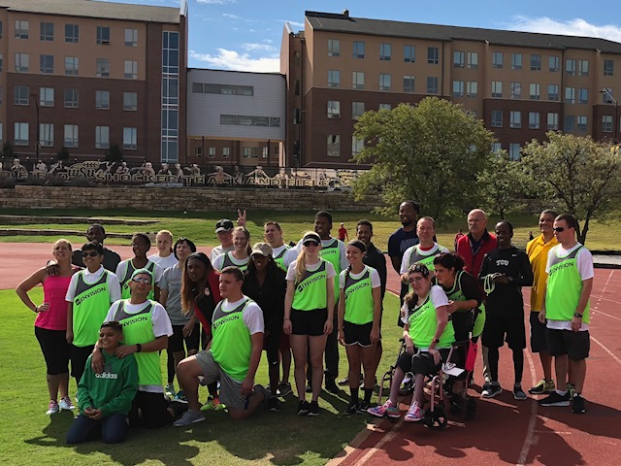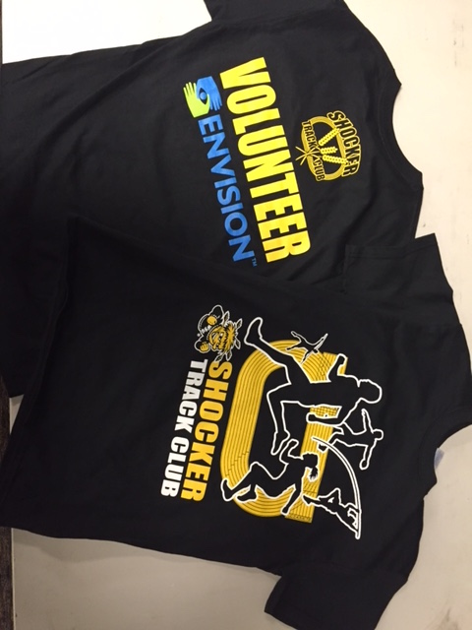  

Shocker Track Club

#### ShockerTrackClub.com

2018 - 2019

The Shocker Track Club is affiliated with USA Track & Field through the Missouri Valley Association. Membership in USATF is strongly encouraged for Volunteers. USATF Membership information can be found at www.usatf.org.

# USATF Affiliation

STC is proud to partner with Envision, Inc., (envision.org) as a sponsor for the Volunteers Corp. Envision provides support for the purchases of Volunteers Corp t-shirts.

Envision

The Shocker Track Club Officials and Volunteers Corp operates under the auspices of the Shocker Track Club Board of Directors and Wichita State Track and Field.

**The Mission of the Shocker Track Club Officials and Volunteer Corp is to provide high-quality, knowledgeable, and ethical officiating services to ensure that Wichita State University, and Shocker Track Club, meets are planned and facilitated in strict compliance with applicable rules and regulations.**

Volunteers Corp

# Mission and Vision

The Shocker Track Club (STC) is a 501(C)(3) organization that helps support Wichita area Track and Field and Cross Country activities.

Periodic meetings of Volunteers are held to discuss matters of importance. Watch ShockerTrackClub.com for details.

Envision (www.envisionus.org), a national organization whose Mission is “To improve the quality of life and provide inspiration and opportunity for people who are blind or visually impaired through employment, outreach, rehabilitation, education and research” is the sponsor of the STC Volunteers Corp t-shirts. STC supports Envision’s efforts by planning and facilitating a 100m Dash for blind and visually impaired athletes at its STC Outdoor Masters Meet in September, and assisting Wichita State University Track and Field in facilitating a similar event at their KT Woodman Track Classic in April.

Envision

Volunteers are individuals that assist in facilitating a meet but do not have Officiating responsibilities. Examples include - but are not limited to – throwing event implement retrievers, bar setters, pit-rakers, meal servers, event board updaters, Hip number providers, etc. Anyone is welcome to volunteer. We ask that volunteers be at least ten (10) years old.

The Shocker Track Club hosts an annual USA Track and Field sanctioned Officials’ Certification Clinic. The clinic is typically held in conjunction with a Wichita State University meet so that prospective Officials can receive classroom, and real-time, training on the same day. Information about certification can be found on the USA Track and Field website at http://www.usatf.org/groups/officials/.

### Interested in Becoming and Official?

**Leadership Meetings**

# Amenities

# 0

### Program Managers

The Shocker Track Club Volunteers Group is co-managed by the Director of Volunteers and the Wichita State University Assistant Director of Track and Field. They are responsible for identifying, training, and assigning Volunteers to assist in facilitating Wichita State University and Shocker Track Club meets.

1845 Fairmount

Wichita, Kansas 67260

(316) 978-5544

volunteers@shockertrackclub.com

STC MISSION

LEADERSHIP

VOLUNTEER PROGRAM