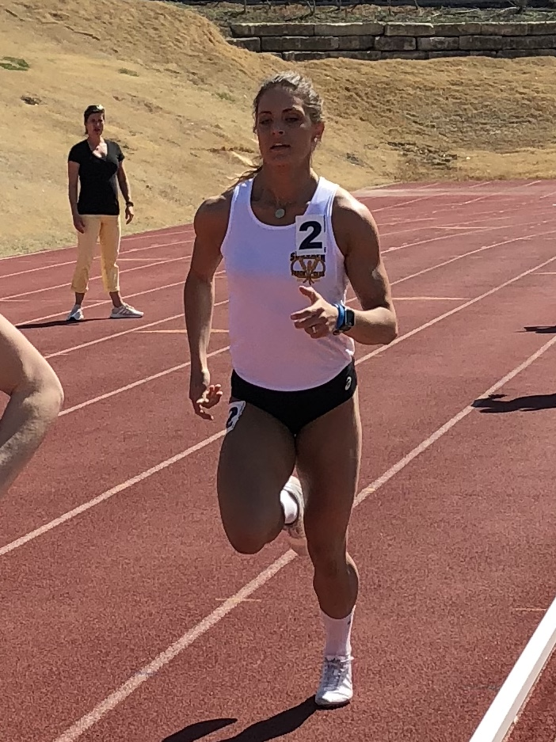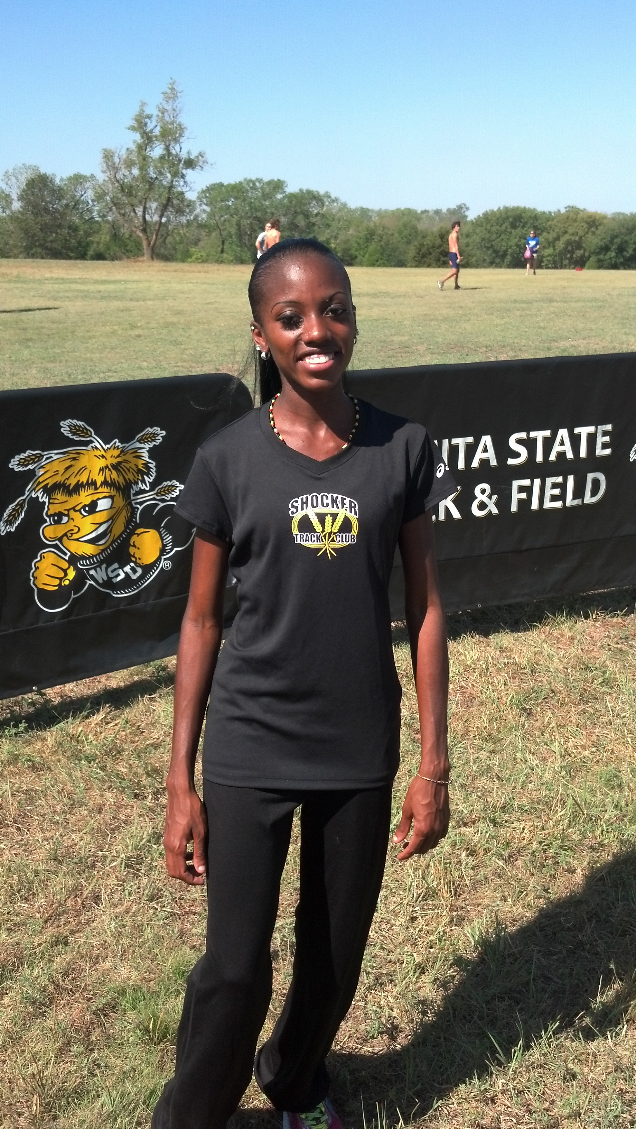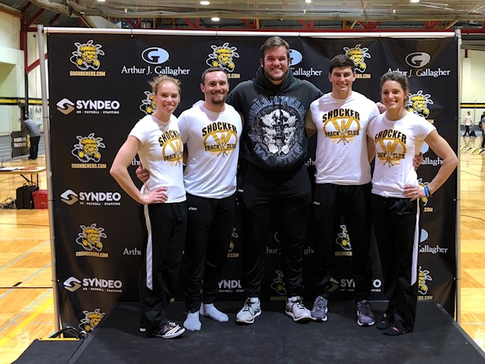 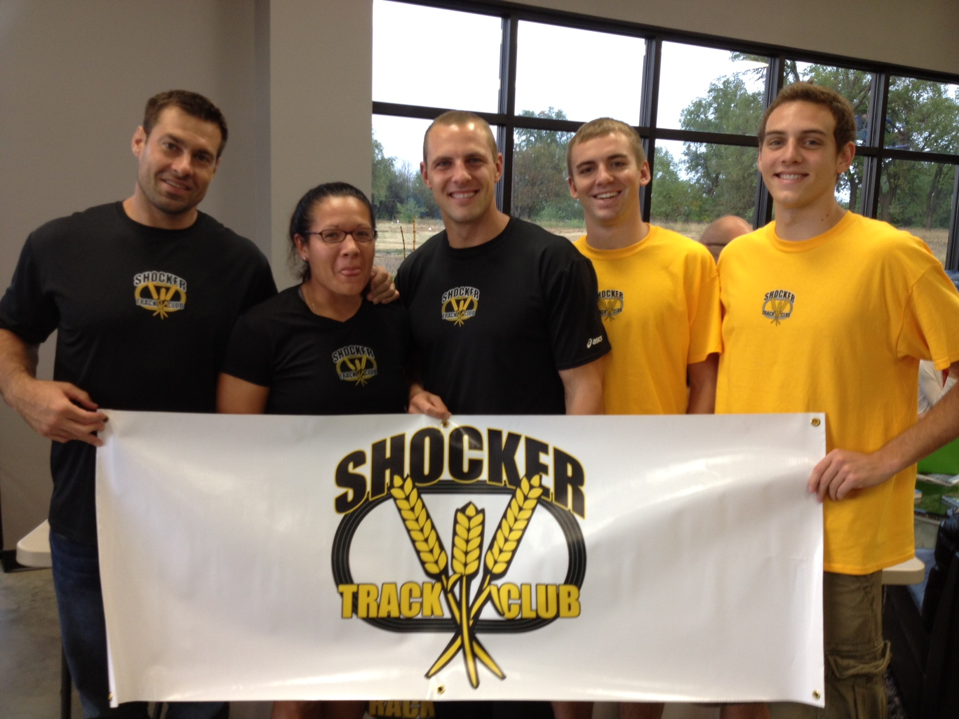

**2018 – 2019 Elite Team Roster**

**Skylar Arneson Throws**

**Dominic Artis Sprints**

**Aaron Babbidge Sprints**

**Chelsea Baker High Jump**

**Austin Bahner Multi-Events**

**Jaimie Bookout Pole Vault**

**Isaac Clark Distance**

**Meghan Holmes Horizontal Jumps**

**Airick Johnson Hurdles**

**Brittany Kallenberger Pole Vault**

**Tyler Knight Pole Vault**

**Nikki Larch-Miller Multi-Events**

**Joshua Manuel Sprints**

**Tonya Nero Long Distance**

**Chris Peters Multi-Events**

**Gavyn Yetter Multi-Events**

#### ShockerTrackClub.com

Shocker Track Club

Elite Team

2018 - 2019

**SPONSORS**Sponsors are needed! Contact [elite@shockertrackclub.com](mailto:elite@shockertrackclub.com) to donate!

**TEAM LEADERSHIP**  
The Leadership of the Elite Team provides direction of the program, support, and a mechanism for communication. Leadership also works with athletes to design and enhance the program to provide support and amenities for athletes to assist in identifying sponsors, sources for services, and financial support.

Director - John Wise

Head Coach - JK Kornelson  
Athlete Liaison - Tyler Knight

**COACHING, PRACTICE and WORKOUTS**  
Practice and workout strategies can be developed and tailored for athletes by the Team Head Coach. Athletes based in Wichita may also arrange for the Head Coach to assess their workouts and performances at meets. Athletes may also use their own coaches. Practice time is available during the indoor season at the Wichita State University Heskett Center. Full access to the Heskett Center workout venues is provided. Access to Wichita State University’s Cessna Stadium is providing during the outdoor Season.

**AMENITIES**Athletes selected for team membership are provided with a team uniform (singlet, t-shirt, full warm-up suit), and other STC accessories. Agreements are in place for access to massage therapy and similar services. Athletes must provide their own black or white shorts/bottoms.

**TEAM MEMBER REQUIREMENTS**STC Elite members are expected to compete at an elevated level of track and field, serve as positive role models, and represent STC and the community in a professional manner. Qualifying performances must be within the past three years and achieved at a sanctioned meet.

STC Elite must complete an Agreement with Shocker Track Club, be a current USATF member, pass the USATF background check, and abide by the USATF Code of Conduct. Generally, all members must reside in Kansas, but residence in the greater Wichita area is strongly preferred.

**GENERAL OVERVIEW**  
The Shocker Track Club Elite Team is comprised of former Wichita State University, and other, post-collegiate athletes invited to compete for the team via an application process, and attaining or efforts to attain certain standards.  A Team Jury reviews all applications for team membership. Membership on the team is review annually.

**ATHLETES’ CONGRESS**   
Elite Team member meetings are held quarterly to help plan the direction of the team. A Facebook page provides for a communication option. Elite Team members are also invited to all STC Board of Director meetings.

The Shocker Track Club (STC) is a 501(C)(3) organization that helps support Wichita area Track and Field and Cross Country activities.

1845 Fairmount

Wichita, Kansas 67260

(316) 978-5544

elite@shockertrackclub.com

Shocker Track Club

LEADERSHIP

ELITE TEAM PROGRAM