**SHOCKER TRACK CLUB**

**Wichita Masters/Open Track & Field Meet**

**USATF Missouri Valley Assoc. Masters Championships**

Saturday, September 29, 2018



Cessna Stadium, Wichita State University, Wichita, Kansas

East of Hillside on 21st Street

 **Entry Fee: $40 per Athlete Sanctioned**

**Open Athletes $15**

**T-Shirts available for $12. Email size to:**

***Contact: Larry Staton, STCsprinter@gmail.com***

**Online Registration (Link below):**

**If Registered with Direct Athletics:**

<https://www.directathletics.com/upcoming_meets.html>

Instructions for Online Registration attached.

**If NOT Registered with Direct Athletics:**

<https://www.directathletics.com>

The meet is open to all men and women ages 19 through 90+ including Open athletes ages 19-29. Masters athletes ages 30 and older will compete in 5-year age groups (i.e. 30-34, 35-39 and so on). Several age groups may race in the same race/final. Medals awarded according to Age Group. ***Age Groups determined by age, as of 9/29/18***

***To receive a USATF Championships Medal, athletes must have a current USATF Membership.***

***Non USATF members will receive Wichita Masters/Open medals.***

**--------------------------------------------------------------------------------------------------------------------------------------**

**8:30 a.m. FIELD EVENTS Schedule To Be Determined**

**Hammer Throw, Weight Throw, Super Weight Throw, Discus, Shot Put,**

**Long Jump, Standing Long Jump, Triple Jump, Javelin**

**Pole Vault (Progressive Heights)**

**High Jump (Progressive Heights)**

**11:00 A.M.** --------- Envision 100 Meter Dash

**1:00 P.M. Running EVENTS**

FAT times for the following running events:

**1:00** --------- 4X800 Meter Relay

**1:10** --------- 3000 Meter Run

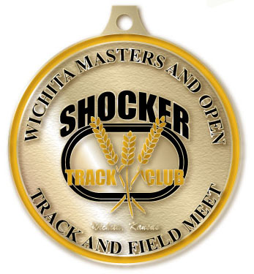

**1:30** --------- 100 Meter Dash (Masters & Open)

**1:45** --------- 800 Meter Run

**2:00** --------- 55 Meter Dash

**2:15** -------- 80/100/110M Hurdles (27” Hurdles available)

**2:35** --------- 200 Meter Dash

**2:50** ---------1500 Meter Racewalk

**3:15** -----------300 M Dash

**3:30** -----------Mile and1500 Meter Run

**3:45** -----------300/400 M Hurdles

**4:00** ---------- 400 Meter Dash

**4:15** ----------- 5,000 Meter Run

Events will be run according to the above time schedule. No rolling schedule will be applied.