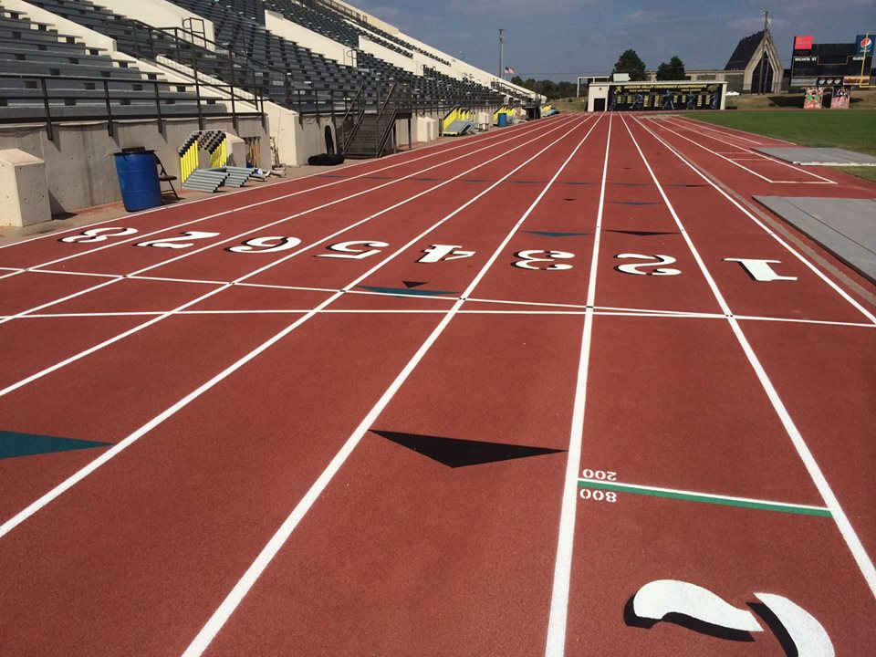 

# Mission and Vision

The Shocker Track Club Open Team is for adult athletes up to the age of 30 and operates under the auspices of the Shocker Track Club Board of Directors. Separate indoor and outdoor seasons provide opportunities for nearly year-round training.

**The Mission of the Shocker Track Club Open Team is to provide opportunities for post collegiate athletes to continue to compete in track and field under the framework of USATF guidelines.**

# USATF Affiliation

The Shocker Track Club is affiliated with USA Track & Field through the Missouri Valley Association. Membership in USATF is not required for Shocker Track Club Open team members, but it is strongly encouraged because of the many benefits. Details are available at www.USATF.org.

Open Team

#### ShockerTrackClub.com

Shocker Track Club

2017-2018

Open Team committee meetings are held annually. Watch www.ShockerTrackClub.com for details.

**Leadership Committee Meetings**

Practice and workout strategies have been developed by the Wichita State University Track & Field Coaching staff along with input from experienced athletes. Practice time is available during the indoor season at the Wichita State University Heskett Center and Wichita State University Cessna Stadium during the outdoor season.

### Coaching and Practice

The Shocker Track Club Open team is managed by the Director of the Open Team who is responsible for planning training activities for athletes. Contact Dylan Hartnett at openteam@shockertrackclub.com.

# Volunteerism - Priceless

STC Open Team members are asked to help with the Wichita State University KT Woodman Track Classic and Herm Wilson Indoor. WSU Track and Field coaches and athletes help make STC sponsored meets & practices possible.

This membership includes a Shocker Track Club black singlet and access to the Wichita State University Heskett Center for indoor practice time between mid-November and mid-February on select days.

This membership includes all of the benefits of the Black Membership plus access to the WSU Cessna Stadium track for evening practice between April and July on select days This membership also offers free participation in the WSU Summer Series Track Meets (Thursday nights) at Cessna Stadium during June and July. In addition, all STC Gold Members receive a 25% discount on registrations for STC sponsored meets.

1845 Fairmount

Wichita, Kansas 67260

(316) 978-5544

masters@shockertrackclub.com

# STC Gold Membership – $100 annually

STC MISSION

The Shocker Track Club (STC) is a 501(C)(3) organization that helps support Wichita area Track and Field and Cross Country activities.

# STC Black Membership - $50 annually

# 0

### Program Director

LEADERSHIP

OPEN TEAM PROGRAMS