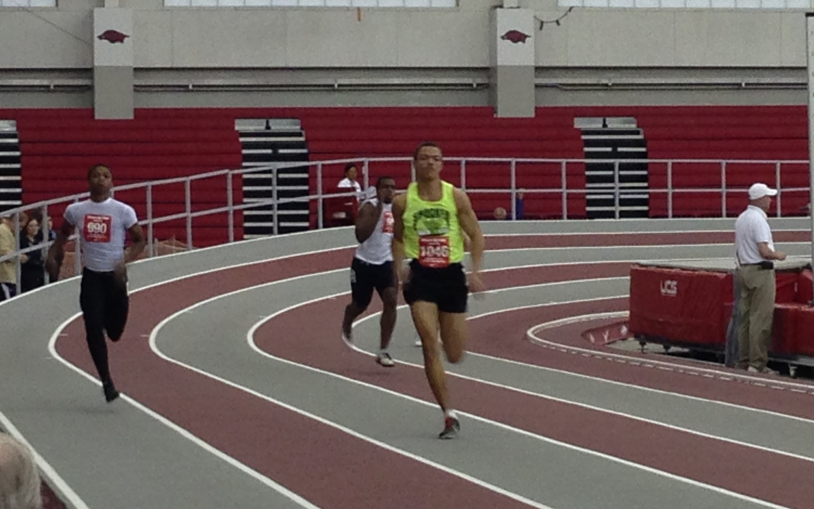  

Youth Team

# Parents

Parents are important to the success of the athlete and the track club and we ask the parents to observe the following:

* Consider volunteering!
* Maintain a positive attitude
* Pay all fees in a timely manner
* Realize that once an athlete is at a given facility, they are under the supervision/jurisdiction/guidelines of the STC Youth Team management and coaching staff
* Ensure that the athlete is at practice and at meets on time
* Remain in the seating area at practice and meets
* Ask questions of STC Youth management and coaches at an appropriate time and in an appropriate manner

#### ShockerTrackClub.com

The Shocker Track Club Youth Team operates under the auspices of the Shocker Track Club Board of Directors. Separate indoor and outdoor seasons provide opportunities for nearly eight months of training.

**The Mission of the Shocker Track Club Youth Team is to provide opportunities for youth to compete in track and field from an introductory level, to high-level competition, under the framework of USATF guidelines.**

# Mission and Vision

Shocker Track Club

Outdoor 2015

All practices are held at Wichita State University’s Cessna Stadium Track. Practices begin April 21, 2015, and continue through July 29, 2015. In April, practices are held on Tuesday and Thursday from 600p to 700p. In May, practices are held on Tuesday, Wednesday and Thursday from 645p to 815p. In June and July, practices are held on Monday, Tuesday and Wednesday from 645p to 815p.

**Practices**

Join in April for $190; in May for $175; in June for $125. All fees include a STC team t-shirt and participation in the WSU Thursday Night Summer Series Meets at Cessna Stadium.

Fees

In April and May, the focus is on basic training and instruction. Along with the team warm-up, we include daily specific stretches and drills for everyone, from 1st day beginners to experienced athletes. In June and July specific training is provided in sprinting, distance running, and pole vault. Other events will be added as coaches are identified.

### Coaches and Volunteers

All STC Youth Coaches AND key Volunteers are USATF members, and have passed a USA Track & Field background check. Coaches “deliver” strategies developed by the Wichita State University Track & Field Coaching staff.

Coaches are responsible for the day-to-day training, practices, meet day preparation and coaching, as well as relaying information pertaining to meet day entries to parents, etc. Volunteers can assist in the following areas:

- Team Parents // Marketing // Practice facilitation

- Home Meet Management and Support // Fundraising

Informational meetings are held regularly to provide information to parents. Watch ShockerTrackClub.com for details.

**Informational Meeting**

# Events

# 0

1845 Fairmount

Wichita, Kansas 67260

(316) 978-5544

youth@shockertrackclub.com

The Shocker Track Club (STC) is a 501(C)(3) organization that helps support Wichita area Track and Field and Cross Country activities.

### Program Managers

The Shocker Track Club Youth Team is managed by a Director and Assistant Director, the Head Coach, and the Team Mom/Dad. They are responsible for planning and leading all activities, including: team organization, training activities for athletes and coaches, overall training template, oversight of membership activities, and co-direction of any STC Youth home meets.

STC MISSION

LEADERSHIP

YOUTH PROGRAMS