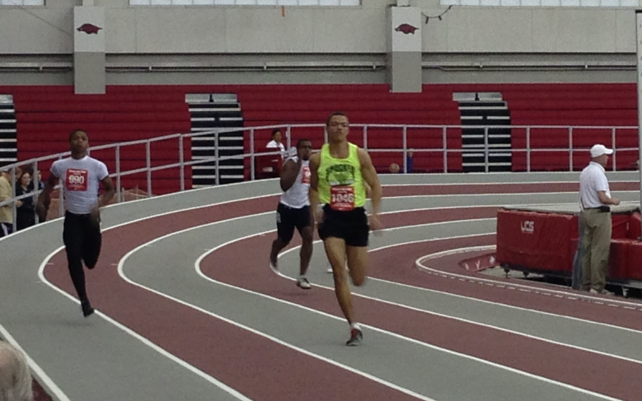  

Youth PV Team

# Parents

Parents are important to the success of the athlete and the track club and we ask the parents to observe the following:

* Consider volunteering!
* Maintain a positive attitude
* Pay all fees in a timely manner
* Realize that once an athlete is at a given facility, they are under the supervision/jurisdiction/guidelines of the STC Youth Team management and coaching staff
* Ensure that the athlete is at practice and at meets on time
* Remain in the seating area at practice and meets
* Ask questions of STC Youth management and coaches at an appropriate time and in an appropriate manner

#### ShockerTrackClub.com

The Shocker Track Club Youth Team operates under the auspices of the Shocker Track Club Board of Directors. Separate indoor and outdoor seasons provide opportunities for nearly six months of training.

**The Mission of the Shocker Track Club Youth Team is to provide opportunities for youth to compete in track and field from an introductory level, to high-level competition, under the framework of USATF guidelines.**

# Mission and Vision

Shocker Track Club

Indoor 2014-2015

**Practices**

Practices begin November 18, 2014, and continue through February 21, 2015, and are held Tuesday and Thursday from 630p-830p, and Saturday, from 100p to 400p, in the gymnasium at the USD 259-Wichita Northeast Magnet High School. 5550 N. Lycee, in Bel Aire, KS. NE Magnet High is just east of Rock Road on 53rd Street North.

The focus is on basic training and instruction. Along with the team warm-up, we include daily specific stretches and drills for everyone, from 1st day beginners to experienced pole vaulters. Then we begin to take short run vaults working on "specific" details or fundamentals that need improvement in the athlete’s form and making sure that steps are consistent. We will eventually work up to full runs and full vaults focusing on the approach and plant take off. Every athlete is unique, with different physical and mental strengths and weaknesses. Our goal is to find these and work on them making the pole vaulters more confident and complete!

### Coaches and Volunteers

All STC Youth Coaches AND key Volunteers are USATF members, and have passed a USA Track & Field background check. Coaches “deliver” strategies developed by the Wichita State University Track & Field Coaching staff.

Coaches are responsible for the day-to-day training, practices, meet day preparation and coaching, as well as relaying information pertaining to meet day entries to parents, etc. Volunteers can assist in the following areas:

- Team Parents // Marketing // Practice facilitation

- Home Meet Management and Support // Fundraising

Informational meetings are held regularly to provide information to parents. Watch ShockerTrackClub.com for details.

**Informational Meeting**

# POLE VAULT ($160)

# 0

1845 Fairmount

Wichita, Kansas 67260

(316) 978-5544

youth@shockertrackclub.com

The Shocker Track Club (STC) is a 501(C)(3) organization that helps support Wichita area Track and Field and Cross Country activities.

### Program Managers

The Shocker Track Club Youth Team is managed by a Director and Assistant Director, Head Coach, and Team Mom/Dad They are responsible for planning and leading all activities, including: team organization, training activities for athletes and coaches, overall training template, oversight of membership activities, and co-direction of STC Youth home meets.

STC MISSION

LEADERSHIP

YOUTH PROGRAMS