SHOCKER TRACK CLUB
STC Elite Team Fundraiser 300m Sprint Challenge

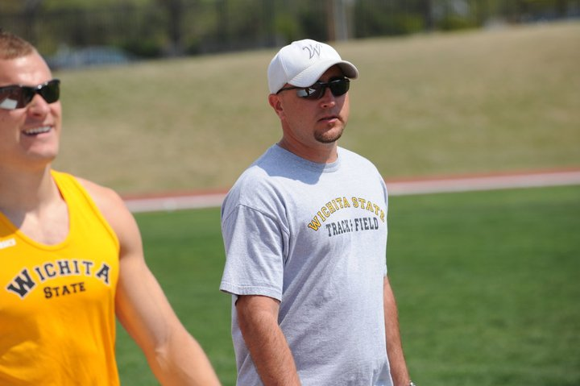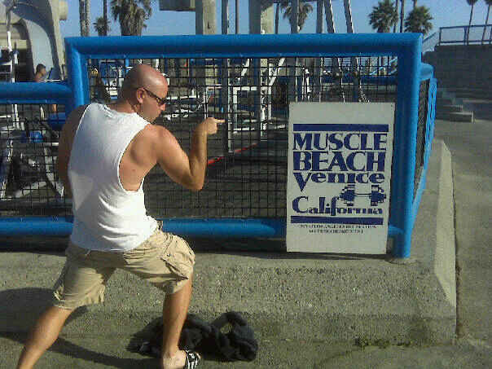
COACH WISE TURNS 40!

Wichita State University’s Assistant Director of Track and Field, and Head Coach of the Shocker Track Club Elite Team, celebrates a milestone birthday on Saturday, October 25, 2014!

To celebrate, John Wise plans to run a 300m sprint in under 40 seconds (his goal is 39.99 seconds) to benefit the Shocker Track Club Elite Team. The sprint takes place at Wichita State’s Historic Cessna Stadium Track at 10:00 a.m.

But Coach Wise needs your help (He is getting old) to meet his goal!

You can help Coach Wise meet his goal as follows:
- $20 DONATE! Donate a minimum of $0.50 (50 cents) per second
- $40 RUN! Think you can beat John in a 300m? Race alongside him! (Reservations are required)
- $60 DUNK! Give Coach Wise an ice bath after the race!

All donations are tax deductible and benefit the Shocker Track Club Elite Team!
The Shocker Track Club Elite Team is comprised of former Wichita State University athletes, and other post-collegiate athletes and requires attaining USATF standards. Three Elite Team athletes competed at the 2012 Olympic Trials in Eugene, Oregon, and others competed at the 2013 and 2014 USATF National Outdoor Championship meets. Athletes selected for team membership are provided with a team uniform and practice/competition shoes, but additional funds are needed to help fund meet entry fees, travel to meets, and practice equipment!
- - - - - - - - - - - - - - - - - - - - - - - - - - - - - - - - - - - - - - - - - - - - - - - - - - - - - - - - - - - - - - - - - - - - - - - - -
Yes! I want to help Coach Wise break 40 seconds in the 300m sprint, and support the Shocker Track Club Elite Team! Make checks payable to Shocker Track Club, Inc. and mail to Shocker Track Club – Attn: Ryan Patton. 1845 Fairmount. Wichita, Kansas 67260
NAME
ADDRESS
EMAIL PHONE

CITY STATE ZIP

DONATION AMOUNT $

I WANT TO RACE AGAINST COACH WISE! YES NO BEST 300m TIME

The Shocker Track Club (STC) is a 501(C)(3) organization that supports Wichita area Track and Field and Cross Country activities.
SHOCKER TRACK CLUB
Elite Team Fundraiser 300m Sprint Challenge

LIABILITY WAIVER
(Must be signed to compete!)

In consideration of being allowed to participate in, or assisting others in participating in The Wichita Masters/Open Meet, its related events and activities, the undersigned acknowledges, appreciates, and agrees that: 1. The risk of injury involved in this program is significant, including the potential for permanent paralysis and death, and while particular skills, equipment, and personal discipline may reduce this risk, the risk of serious injury does exist; and, 2. I knowingly and freely assume all such risks, both known and unknown, even if arising from the negligence of the releasees or others, and assume full responsibility for my participation; and 3. I willingly agree to comply with the stated and customary terms and conditions for participation. If, however, I observe any unusual significant hazard during my presence or participation, I will remove myself from participation and bring such to the attention of the nearest official immediately; and, 4. I, for myself, and on behalf of my heirs, assign personal representatives and next of kin, hereby release and hold harmless The Shocker Track Club, Inc, their officers, officials, agents and/or employees, other participants, sponsoring agencies, advertisers, sponsors, and, if applicable, owners and lessors of premises used to conduct the event (“releasees”), and in particular, Wichita State University, with respect to any and all injury, disability, death, or loss or damage to person or property, whether arising from the negligence of the releasees or otherwise.

I have read this release of liability and assumption of risk agreement, fully understand its terms,
understand that I have given up substantial rights by signing it, and sign it freely and voluntarily without any inducement.

SIGN HERE TO PARTICIPATE

Participant’s Signature Name of Participant Date
Or, Parent/Guardian’s Signature

By affixing my signature hereto, I attest that I am physically fit and have trained sufficiently for the activities in which I intend to participate and the events I have chosen to enter. The Shocker Track Club, Inc. and its representatives, employees, and volunteers have permission to obtain immediate medical care and I consent to hospitalization, the performance of necessary diagnostic tests, the use of surgery, and/or the administration of drugs in an emergency. I understand that I am responsible for payment of medical expenses.

Name of Insurance Policy:

Physician’s Name: Physician’s Phone #:

Emergency Contact Person: Relationship:

Emergency Contact’s Phone #:

