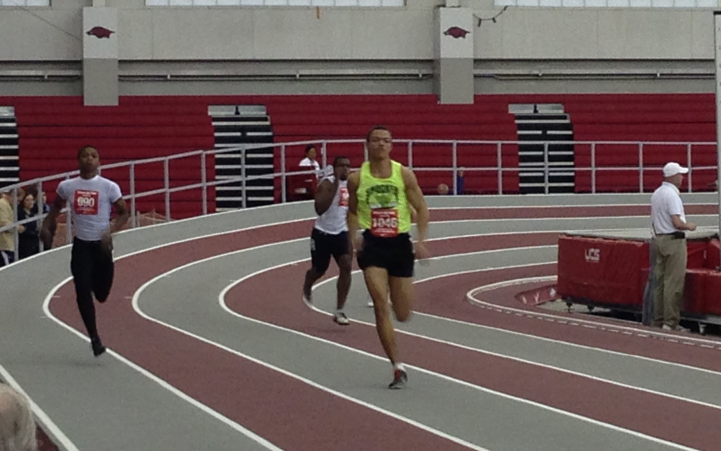  

Youth Team

# Parents

Parents are important to the success of the athlete and the track club and we ask the parents to observe the following:

* Consider volunteering!
* Maintain a positive attitude
* Pay all fees in a timely manner
* Realize that once an athlete is at a given facility, they are under the supervision/jurisdiction/guidelines of the STC Youth Team management and coaching staff
* Ensure that the athlete is at practice and at meets on time
* Remain in the seating area at practice and meets
* Ask questions of STC Youth management and coaches at an appropriate time and in an appropriate manner

#### ShockerTrackClub.com

The Shocker Track Club Youth Team operates under the auspices of the Shocker Track Club Board of Directors. Separate indoor and outdoor seasons provide opportunities for nearly six months of training.

**The Mission of the Shocker Track Club Youth Team is to provide opportunities for youth to compete in track and field from an introductory level, to high-level competition, under the framework of USATF guidelines.**

# Mission and Vision

Shocker Track Club

2013-2014

**Practices**

Practices are typically held at Wichita State’s Heskett Center (indoor) or Cessna Stadium (outdoor) Monday – Thursday.

Informational meetings are held regularly to provide information at the WSU Cessna Stadium Track & Field Team Room. Watch ShockerTrackClub.com for details

**Informational Meeting**

All STC Youth Coaches AND key Volunteers are USATF members, and have passed a USA Track & Field background check.

Coaches are responsible for the day-to-day training, practices, meet day preparation and coaching, as well as relaying information pertaining to meet day entries to parents, etc. Volunteers work under the direction of the

Team Program Managers and can assist in the following areas:

- Team Parents // Marketing // Practice facilitation

- Home Meet Management and Support // Fundraising

Group focuses on developing a particular skill set of advanced athletes with the hope of qualifying for a national team on the youth and/or junior national level.

# Elite– Ages 14-19 – ($310 per season)

* Group focuses on taking competitive skills to the next level – going from good to great, from great to excellent, from excellent to superior! Group will participate in a minimum of three (3)  meets focusing on state and regional competition within USA Track & Field.

# Competition – Ages 8-18 – ($225 per season)

Group focuses on basic training and instruction of the three disciplines within track and field (running, jumping, throwing). Focus is on basic training and fitness, not competition.

# Developmental– Ages 6-16 – ($100 per season)

# 0

### Coaches and Volunteers

1845 Fairmount

Wichita, Kansas 67260

(316) 978-5544

youth@shockertrackclub.com

The Shocker Track Club (STC) is a 501(C)(3) organization that helps support Wichita area Track and Field and Cross Country activities.

### Program Managers

The Shocker Track Club Youth Team is managed by a Director and Assistant Director. They are responsible for planning meets, training activities for athletes and coaches, planning overall training template, oversight of membership activities, and co-direction of STC Youth home meets. Youth Coaches “deliver” strategies developed by the Wichita State University Track & Field Coaching staff.

STC MISSION

LEADERSHIP

YOUTH PROGRAMS