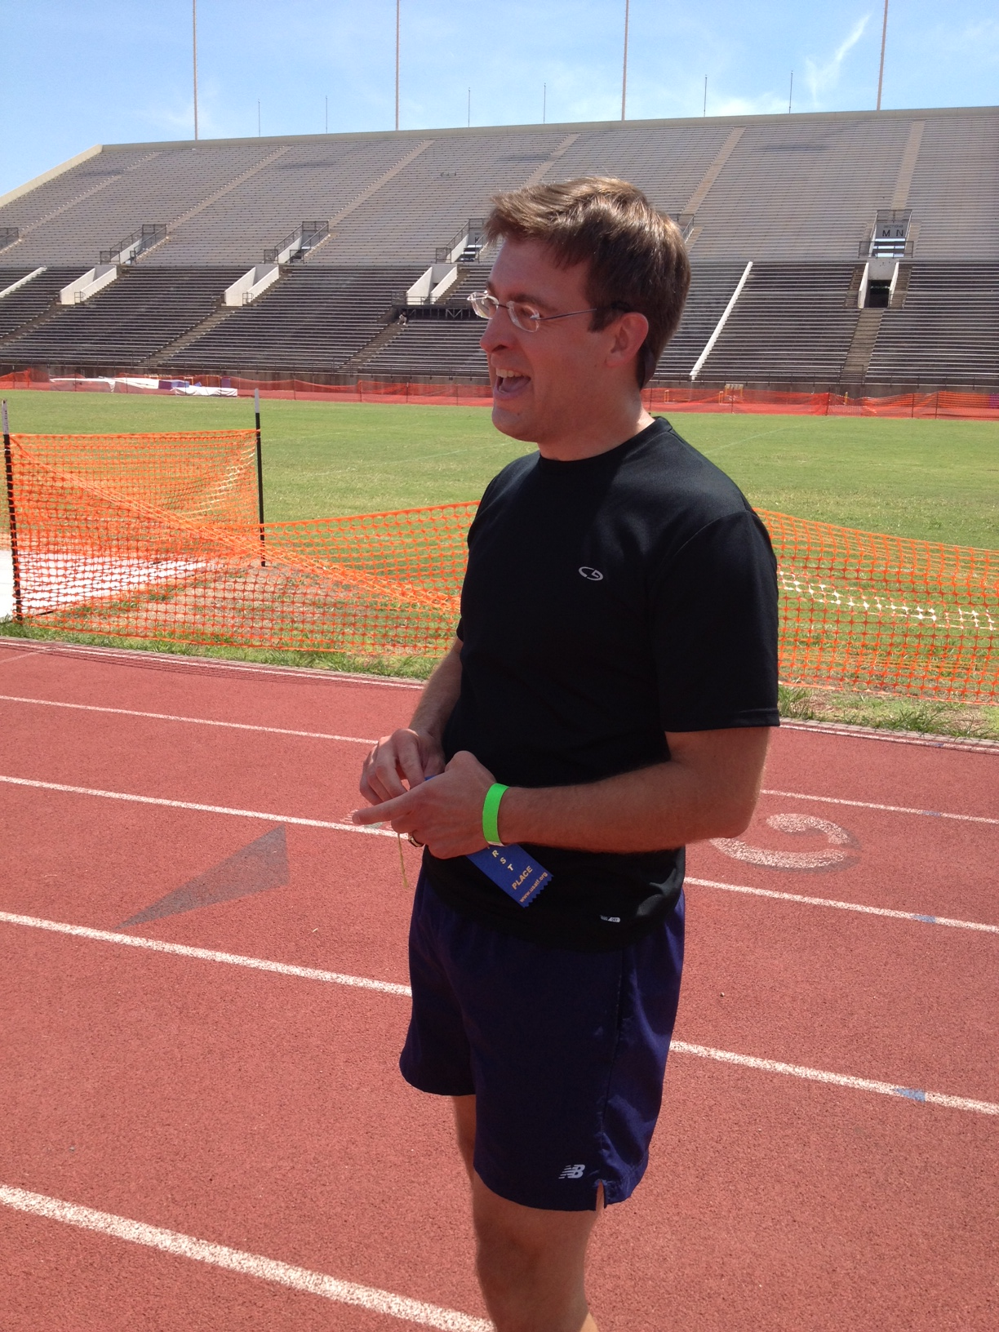 

# Mission and Vision

The Shocker Track Club Masters/Open Team operates under the auspices of the Shocker Track Club Board of Directors. Separate indoor and outdoor seasons provide opportunities for nearly year-round training.

**The Mission of the Shocker Track Club Masters/Open Team is to provide opportunities for post collegiate and mature athletes to compete in track and field under the framework of USATF guidelines.**

# USATF Affiliation

The Shocker Track Club is affiliated with USA Track & Field through the Missouri Valley Association. Membership in USATF is not required for Shocker Track Club Masters/Open team members, but it is strongly encouraged because of the many benefits. Details are available at www.USATF.org.

Masters Team

#### ShockerTrackClub.com

Shocker Track Club

2013-2014

1845 Fairmount

Wichita, Kansas 67260

(316) 978-5544

masters@shockertrackclub.com

# STC Gold Membership – $100 annually

This membership includes all of the benefits of the Black Membership plus access to the WSU Cessna Stadium track for evening practice between mid-April and mid-July from 630p to 800p on Monday, Tuesday, Wednesday and Friday. This membership also offers free participation in the WSU Summer Series Track Meets (Thursday nights) at Cessna Stadium during June and July. In addition, all STC Gold Members receive a 50% discount on registrations for STC sponsored meets and a free T-Shirt for the respective meet.

# Volunteerism - Priceless

STC members are asked to help with at least one of the WSU T&F meets on the schedule. WSU Track and Field coaches and athletes offer resources which make STC sponsored meets & practices possible. We love WSU T&F!

STC MISSION

The Shocker Track Club (STC) is a 501(C)(3) organization that helps support Wichita area Track and Field and Cross Country activities.

This membership includes a Shocker Track Club black singlet and access to the Wichita State University Heskett Center for practice time between mid-November and mid-February on select days from 430p to 600p. $40 renewal.

# STC Black Membership - $50 annually

# 0

Masters/Open Team leadership meetings are held quarterly to at the WSU Cessna Stadium Track & Field Team Room. Watch ShockerTrackClub.com for details.

**Leadership Meetings**

Practice and workout strategies have been developed by the Wichita State University Track & Field Coaching staff along with input from experienced and nationally recognized Masters athletes. Practice time is available during the indoor season at the Wichita State University Heskett Center and Wichita State University Cessna Stadium during the outdoor season.

### Coaching and Practice

The Shocker Track Club Masters/Open team is managed by a Committee. They are responsible for planning meets, training activities for athletes, oversight of membership activities, fundraising, and co-direction of STC Masters/Open home meets.

### Program Managers

LEADERSHIP

MASTERS/OPEN PROGRAMS